WHO/WB MMR and ISO3 Information:

<https://www.iban.com/country-codes>

<https://www.who.int/publications/i/item/9789240068759>

<https://data.who.int/indicators/i/C071DCB/AC597B1>

<https://genderdata.worldbank.org/en/indicator/sh-sta-mmrt>

<https://genderdata.worldbank.org/en/indicator/sh-sta-mmrt?year=2019#idRelatedContent>

About incomplete maternal mortality data:

<https://pmc.ncbi.nlm.nih.gov/articles/PMC10647144/>

Maternal mortality by rural/urban region:

<https://www.thelancet.com/journals/eclinm/article/PIIS2589-5370(24)00232-3/fulltext>

<file:///Users/rosalitarosenberg/Downloads/mmc1.pdf>

<https://dataverse.harvard.edu/file.xhtml?fileId=10198661&version=1.0>

maternal mortality age patterns:

<https://journals.plos.org/plosone/article/file?id=10.1371/journal.pone.0059864&type=printable>

global + regional causes of maternal deaths 2009-20

<https://www.thelancet.com/journals/langlo/article/PIIS2214-109X(24)00560-6/fulltext#supplementary-material>

maternal mortality in adolescents:

<https://www.sciencedirect.com/science/article/pii/S2214109X13701797?ref=pdf_download&fr=RR-2&rr=95e7cee9189c56e2>

<https://ars.els-cdn.com/content/image/1-s2.0-S2214109X13701797-mmc1.pdf>

* Look at this source for adjustments to the proportion of maternal deaths among death of females of reproductive age (PMDF) to calculate MMR

Imputation for clinical structured datasets

<https://bmcmedresmethodol.biomedcentral.com/articles/10.1186/s12874-024-02310-6>

* need to consider the missingness mechanism and pattern of missing data
* there are 3 identified categories for the mechanism of missingness
  + missing completely at random (MCAR)
  + missing at random (MAR)
  + missing not at random (MNAR)

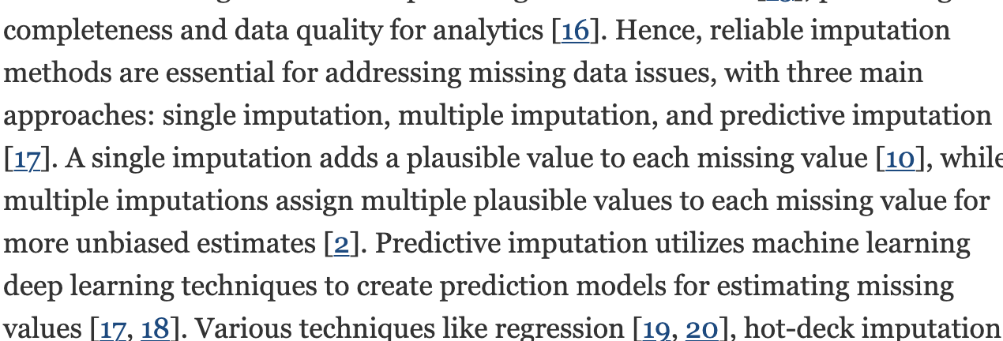

**Survey on missing data in machine learning**

<https://link.springer.com/article/10.1186/s40537-021-00516-9>

MCAR:

* a missing value does not depend on observed or unobserved measurements

MAR:

* the probability for a value to be missing depends on the observed data only

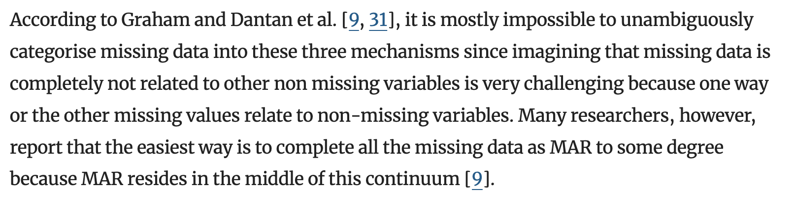

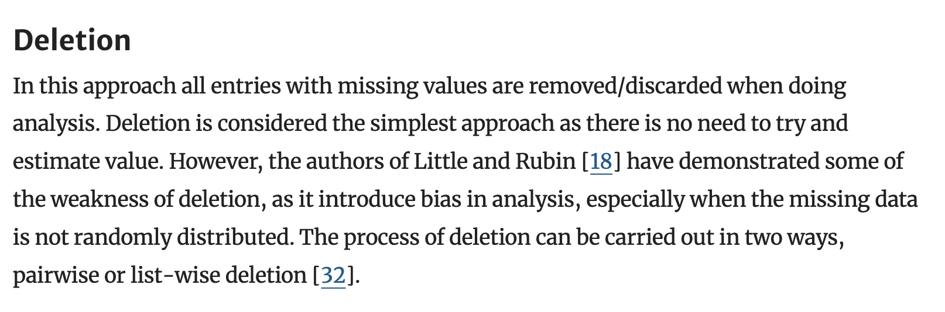 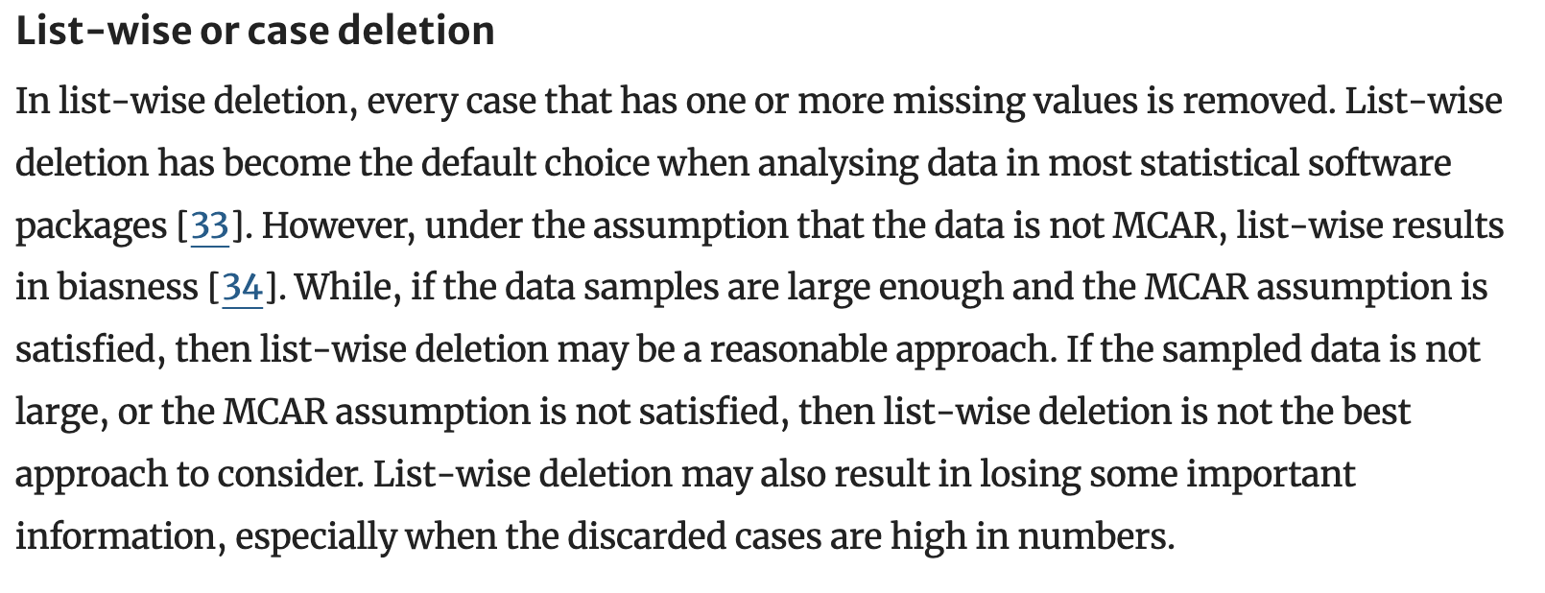

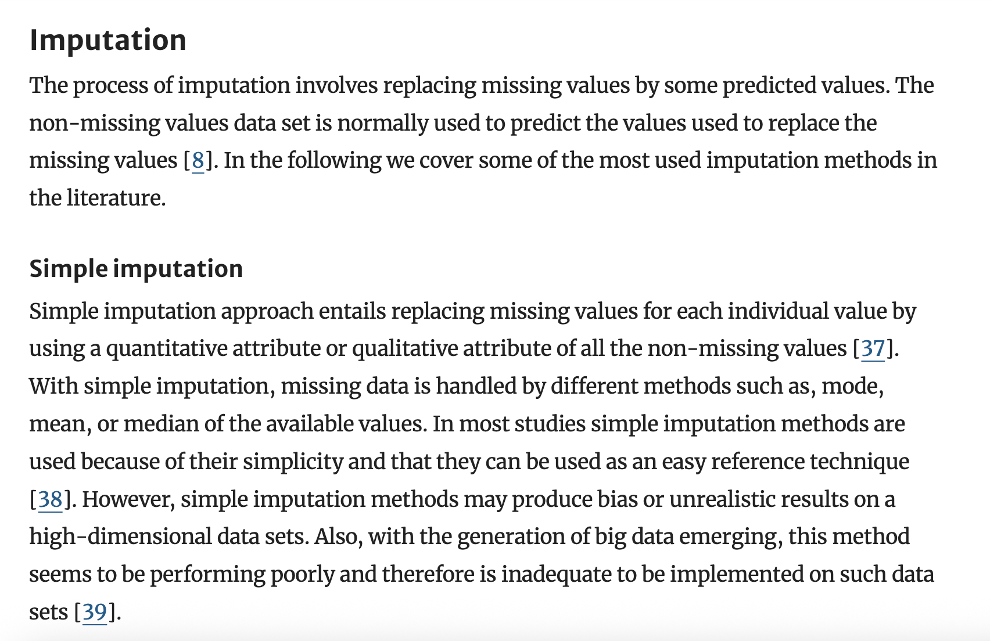

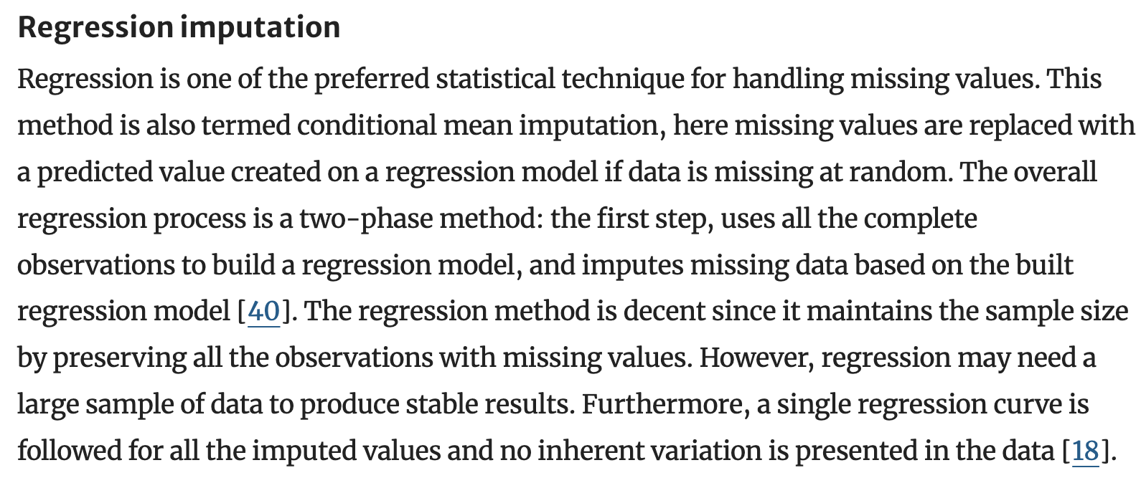

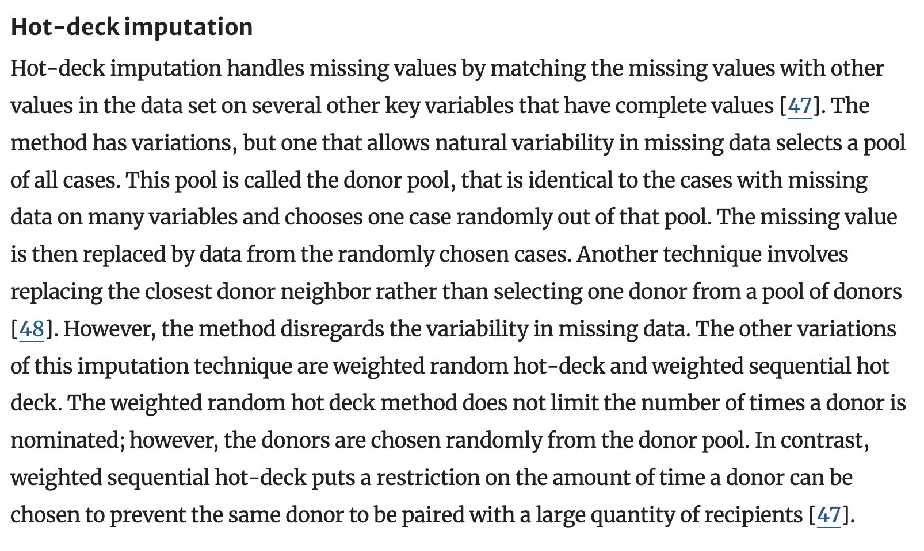

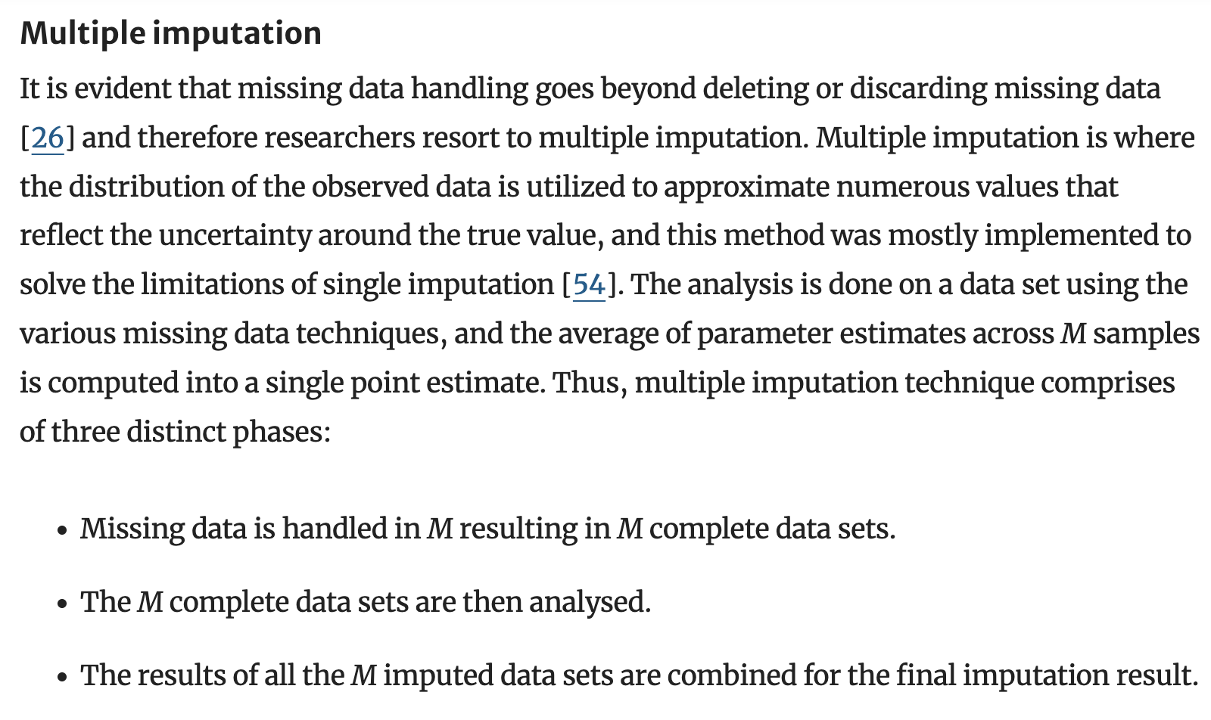

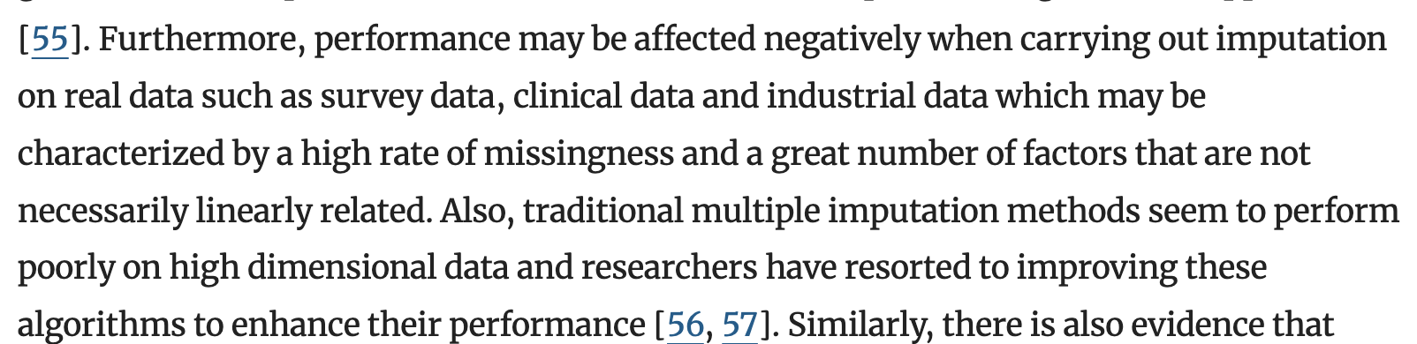

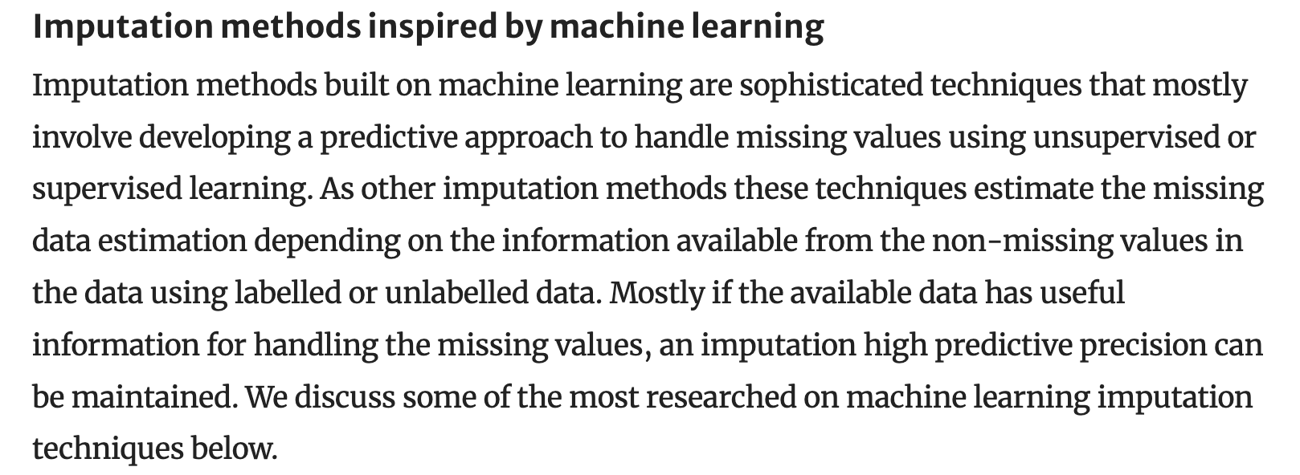 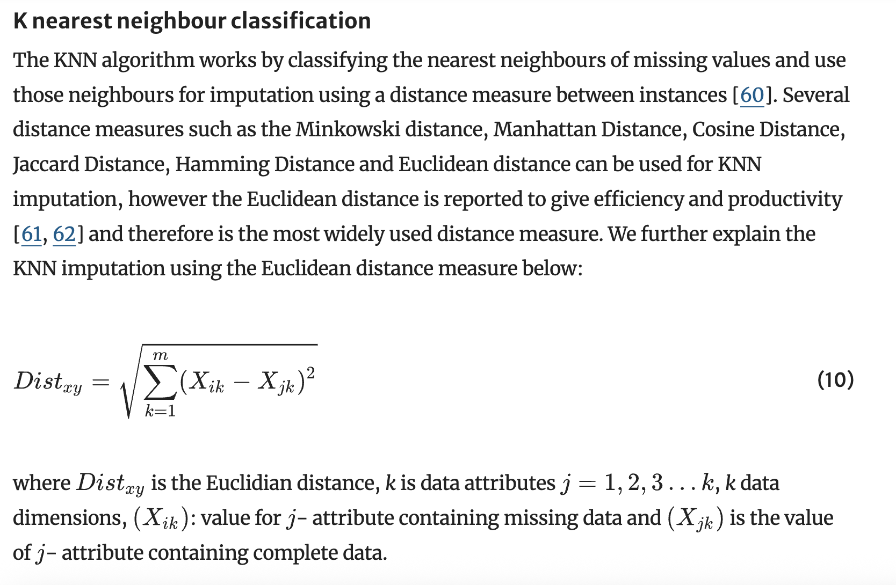

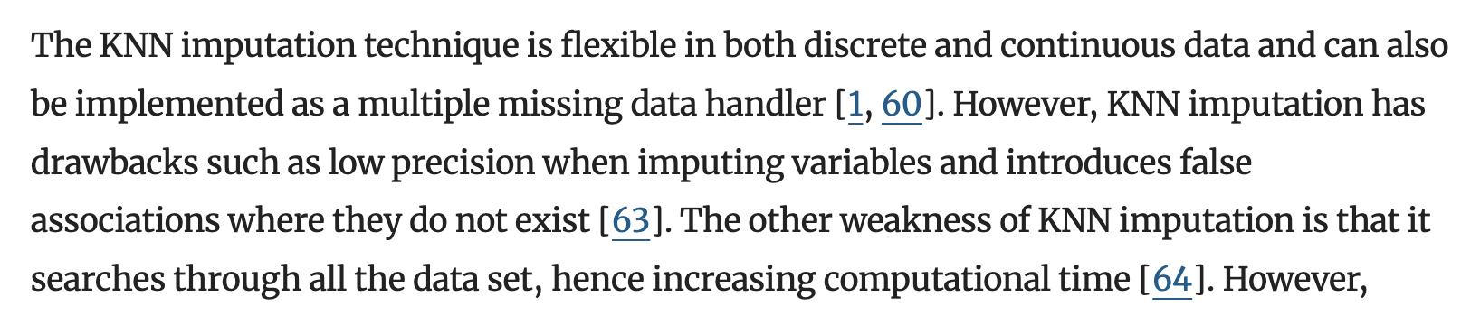

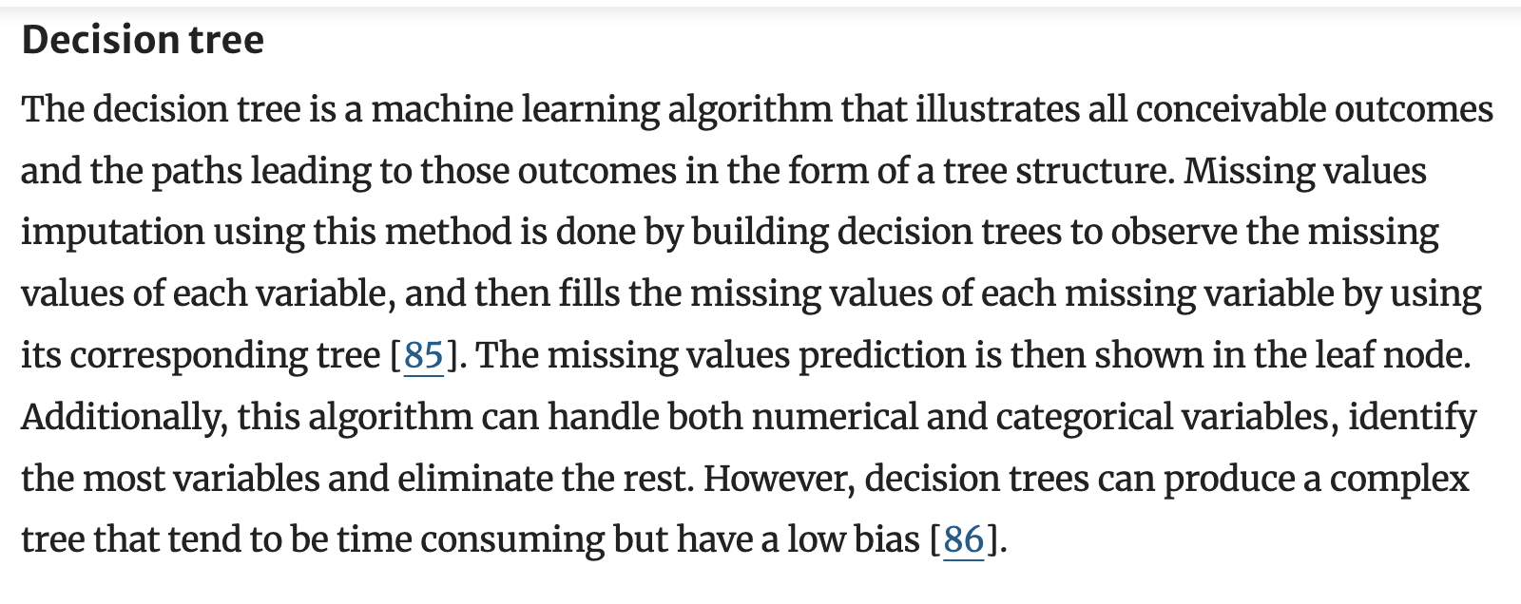

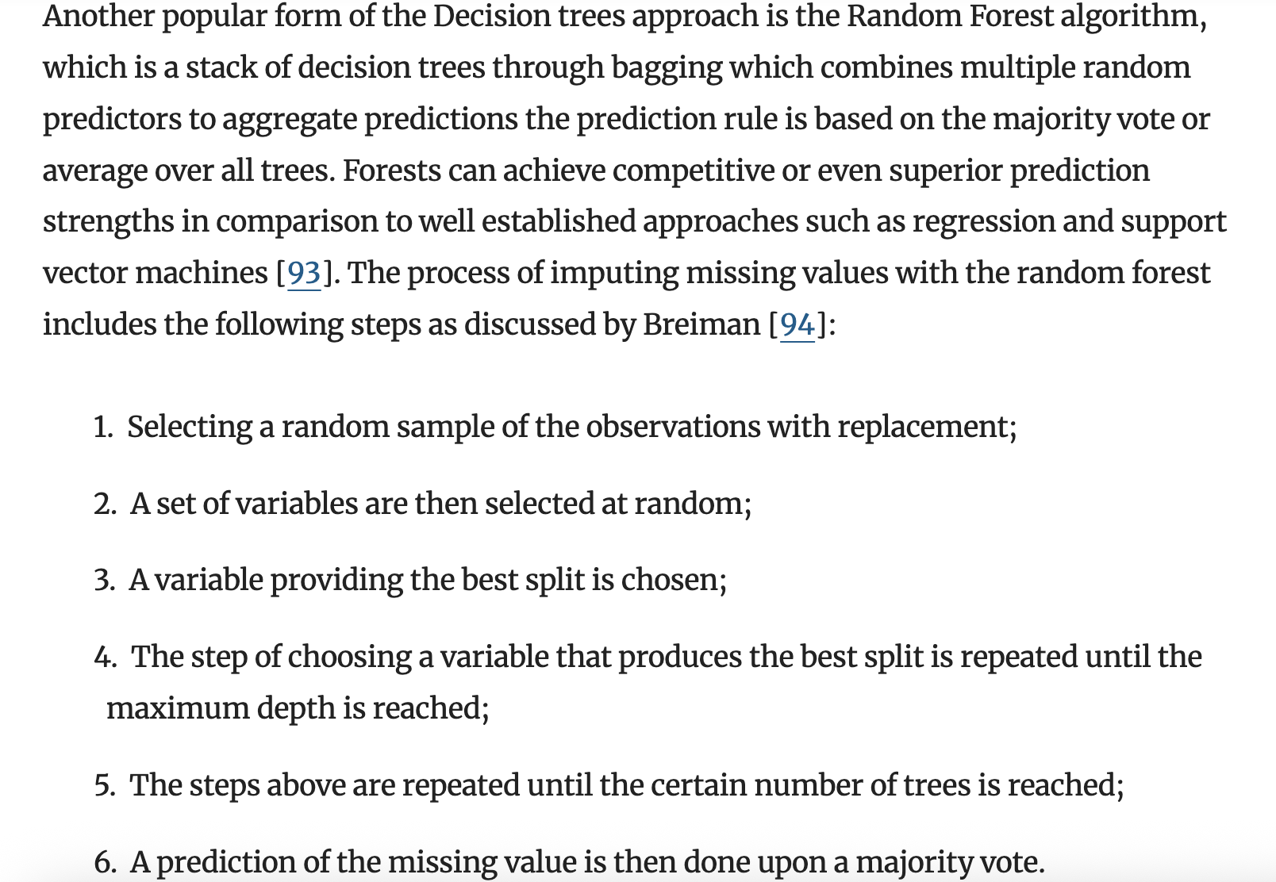

**missing value imputation: a review and analysis of the literature (2006-2017)**

<https://link.springer.com/article/10.1007/s10462-019-09709-4>

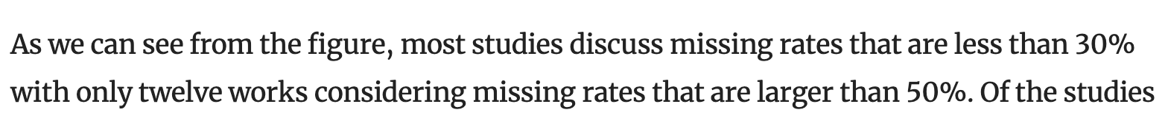

**Decision tree methods**

<https://www.tandfonline.com/doi/epdf/10.1080/08839510902872223?needAccess=true>

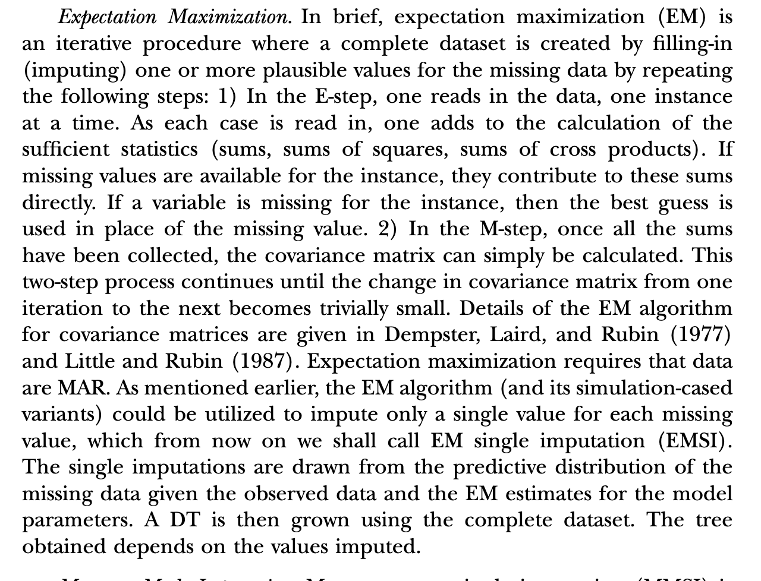

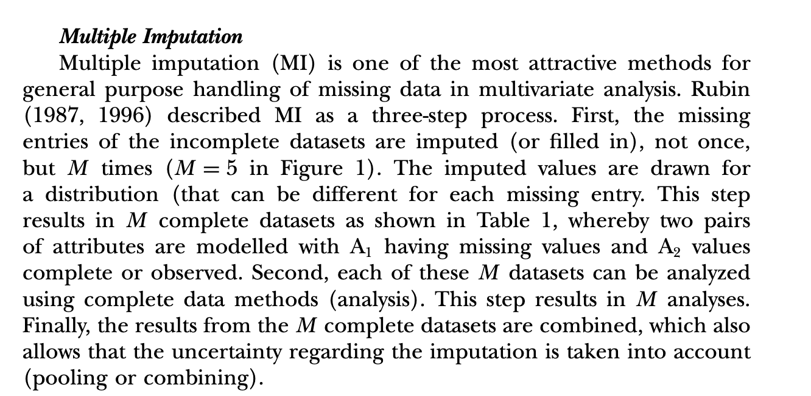

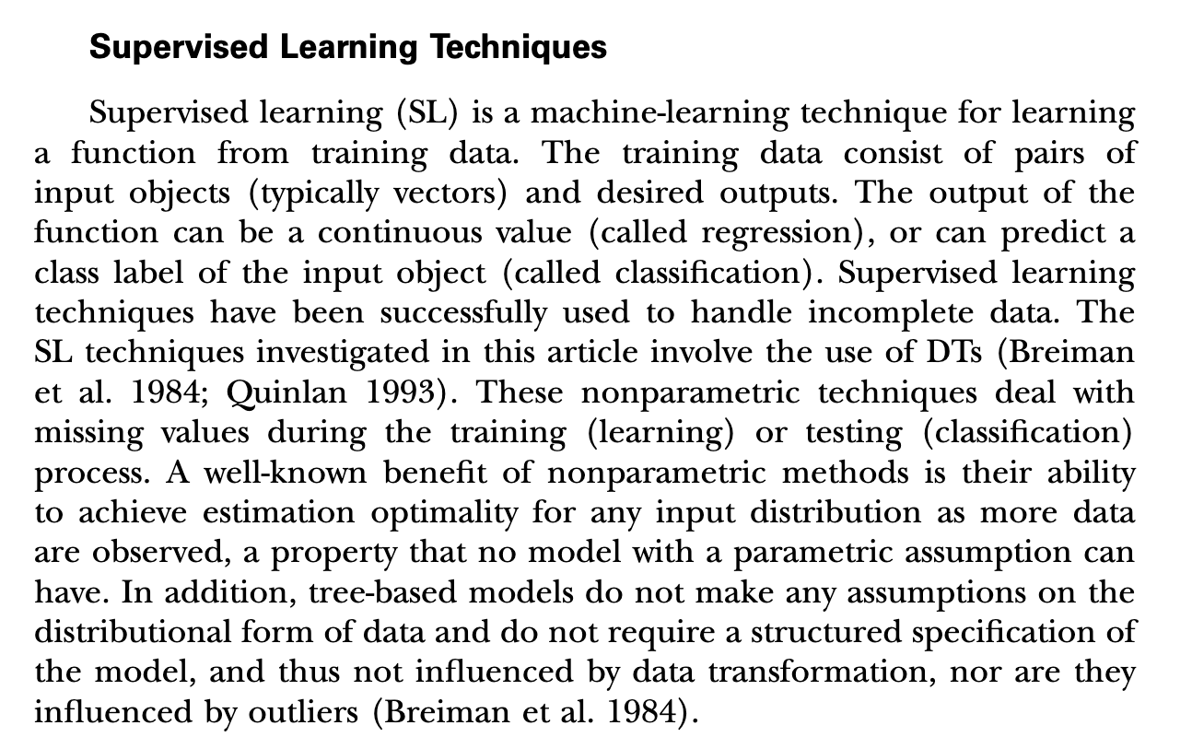

**Missing value imputation in longitudinal measures of alcohol assumption**

[**https://onlinelibrary.wiley.com/doi/epdf/10.1002/mpr.330**](https://onlinelibrary.wiley.com/doi/epdf/10.1002/mpr.330)

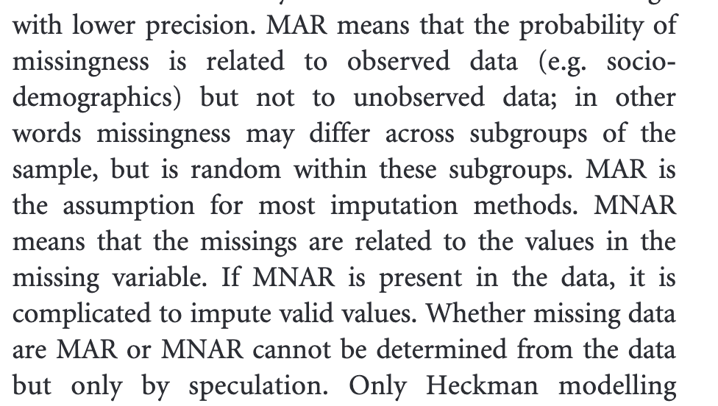

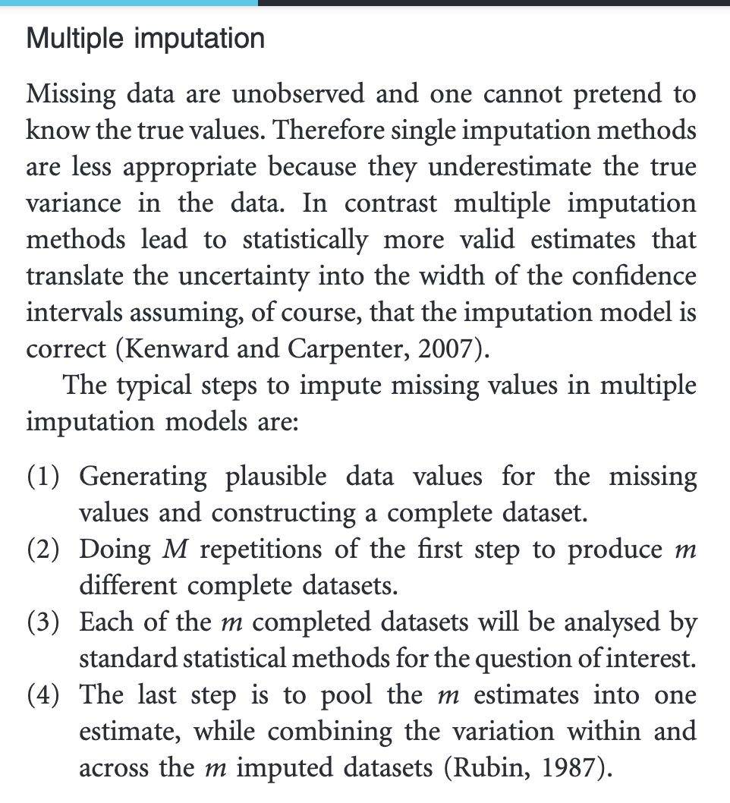

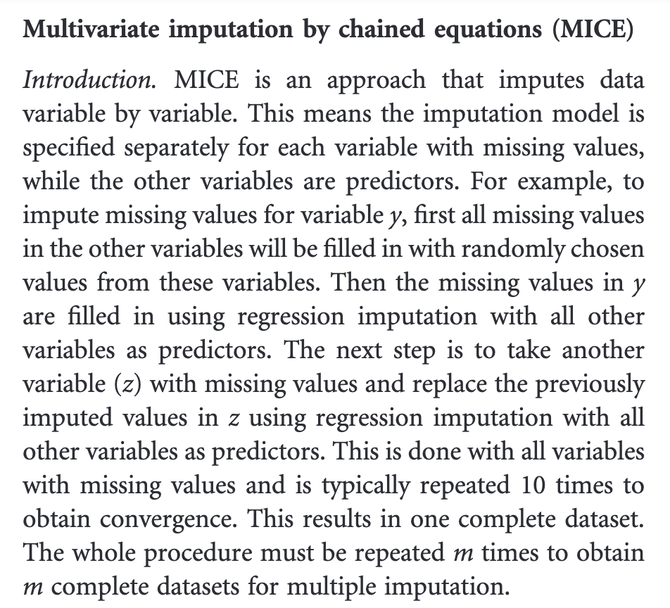

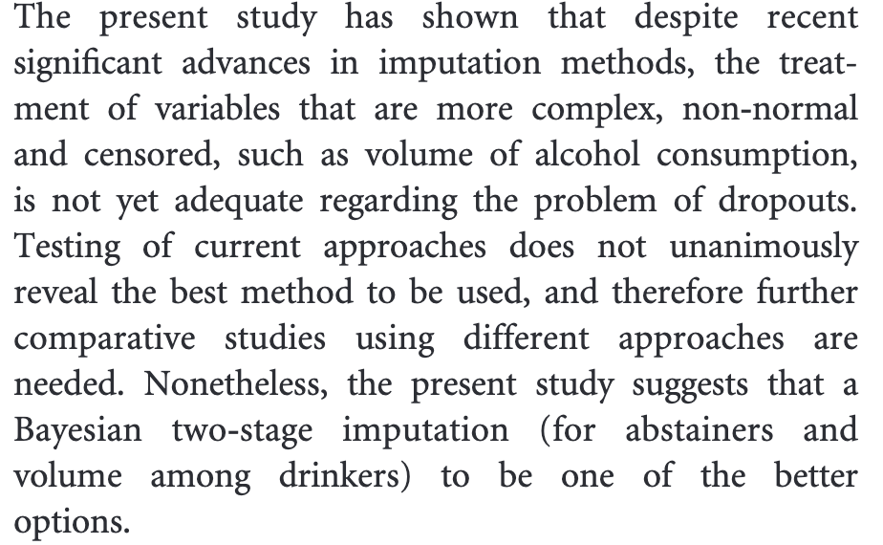

**Comparison of the effects of imputation methods for missing data in predictive modelling of cohort study datasets**

<https://bmcmedresmethodol.biomedcentral.com/articles/10.1186/s12874-024-02173-x>

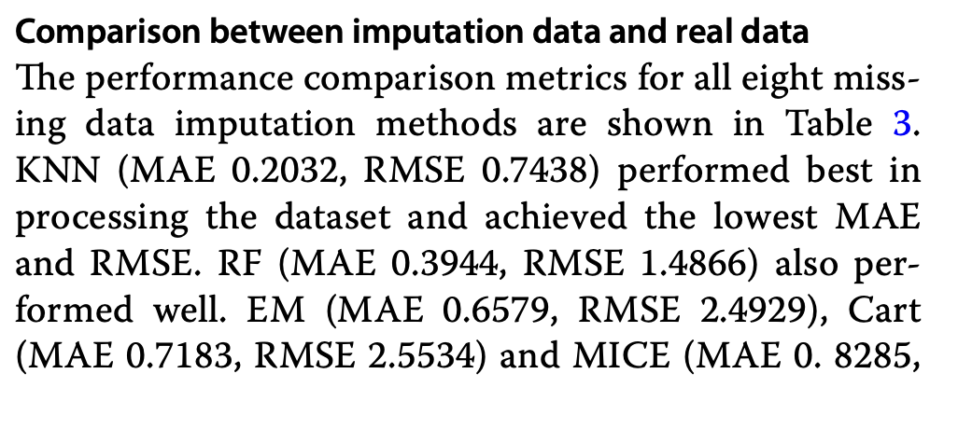 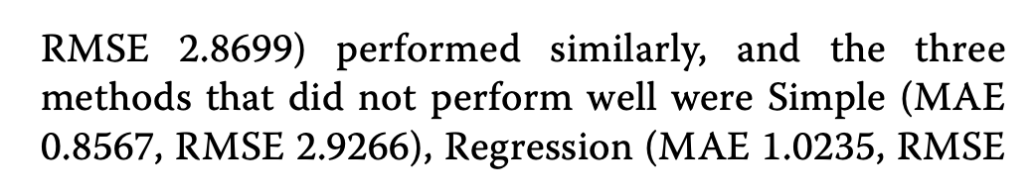 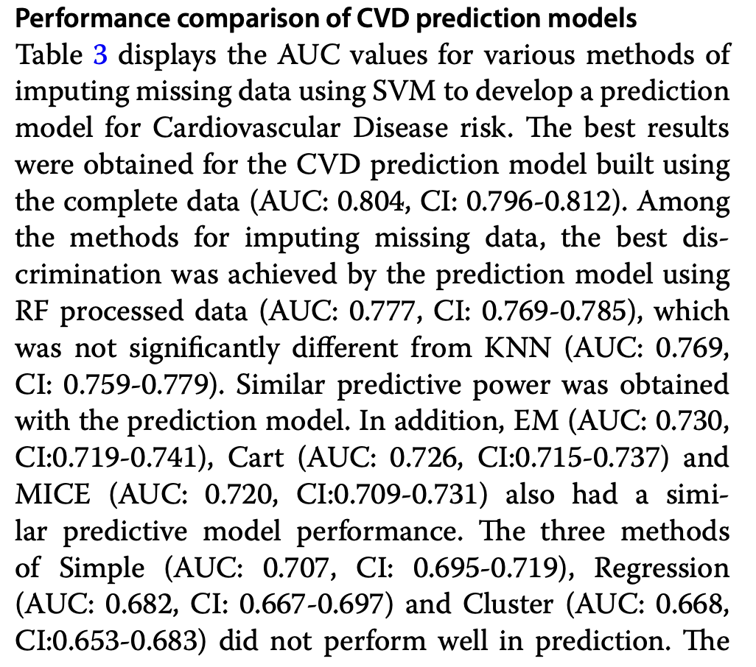 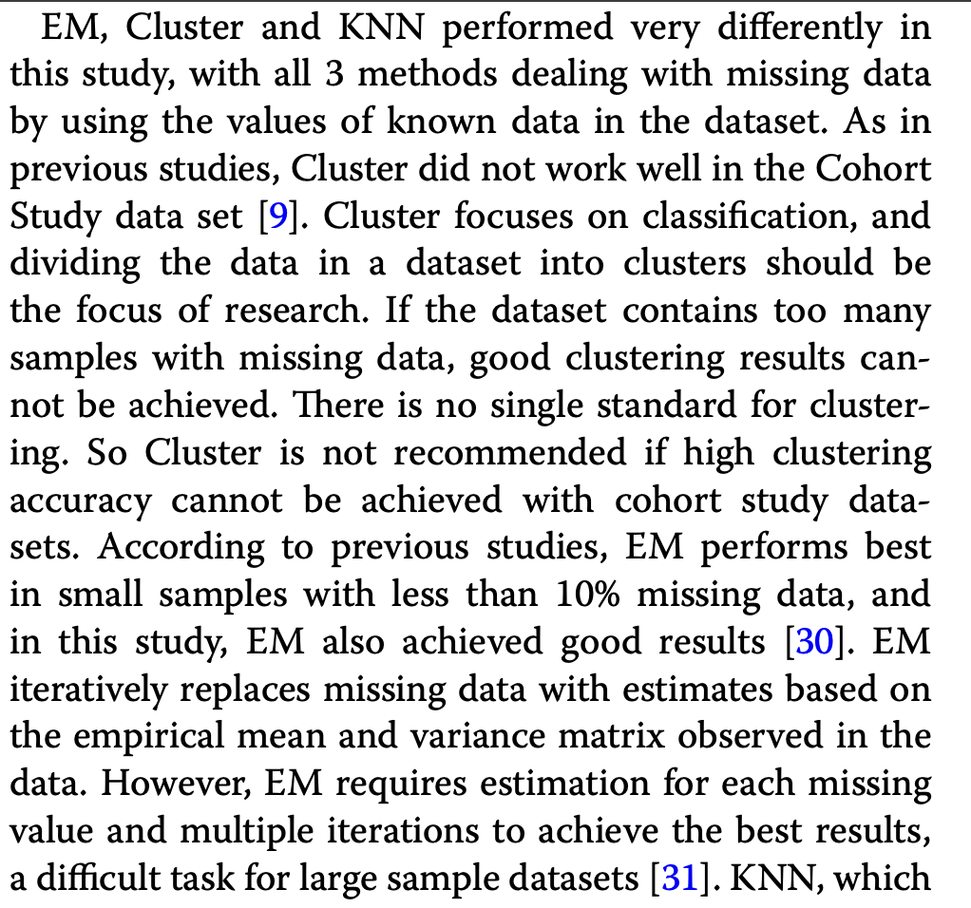 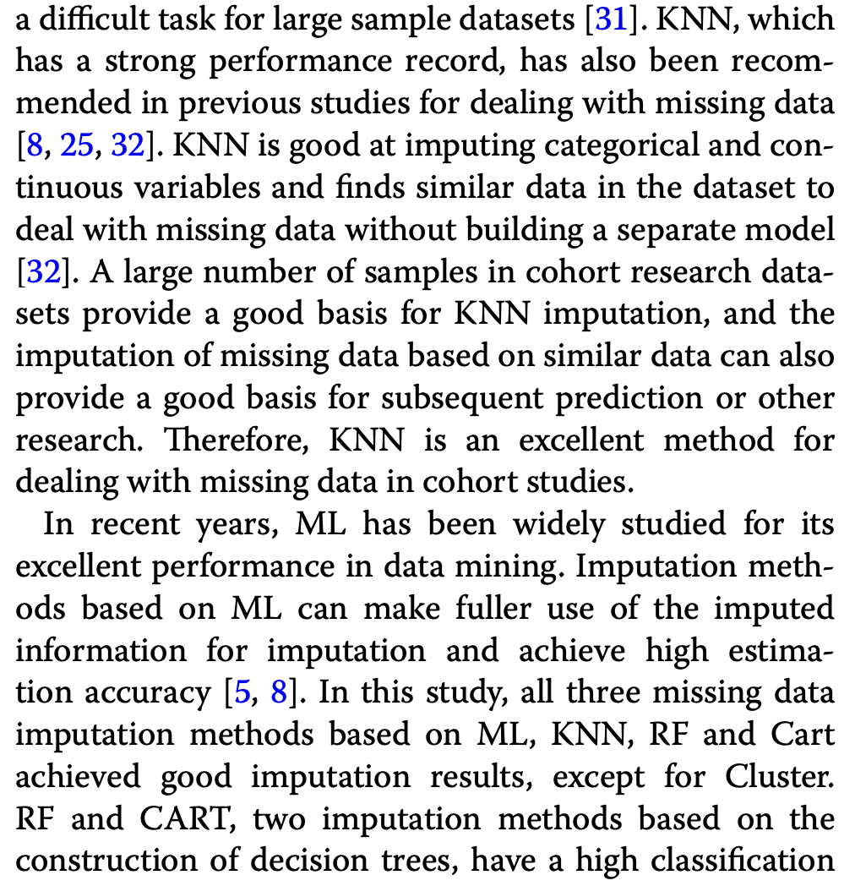

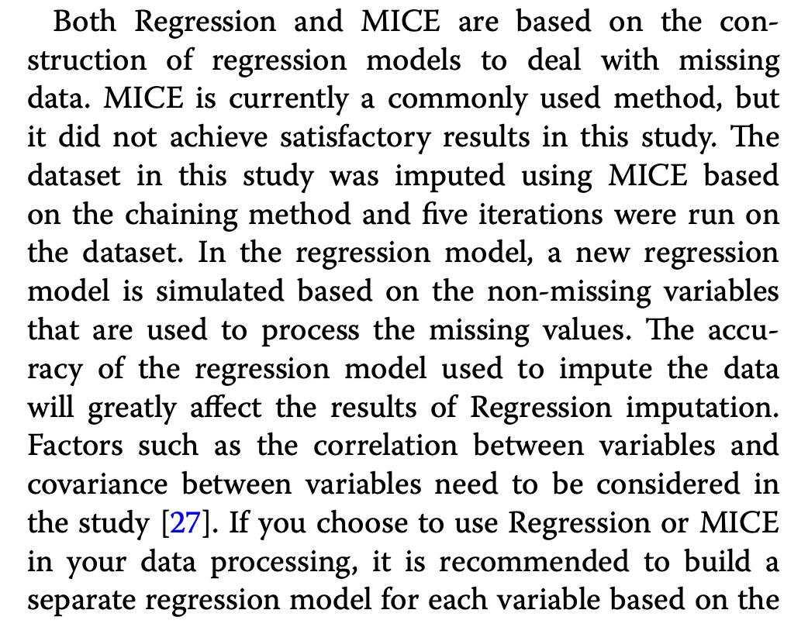

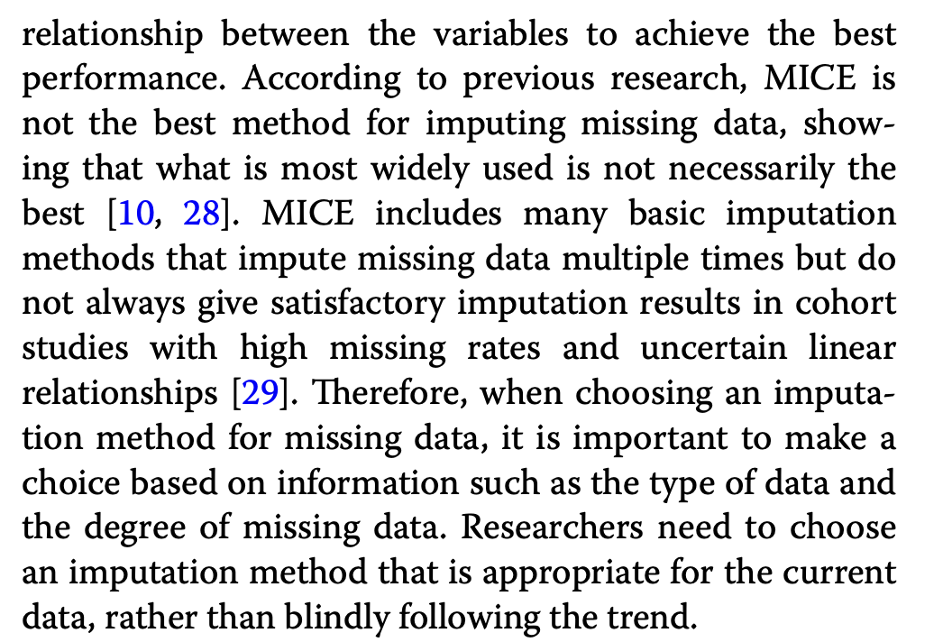

Cohort study, looking at both clinical measures and socioeconomic indicators, like my study

Also periods of dropout, like my study

Handling Missing Data in Health Economics and Outcomes Research (HEOR): A Systematic Review and Practical Recommendations

<https://link.springer.com/article/10.1007/s40273-023-01297-0>



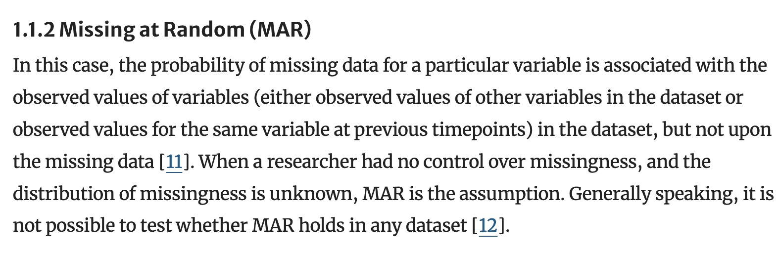

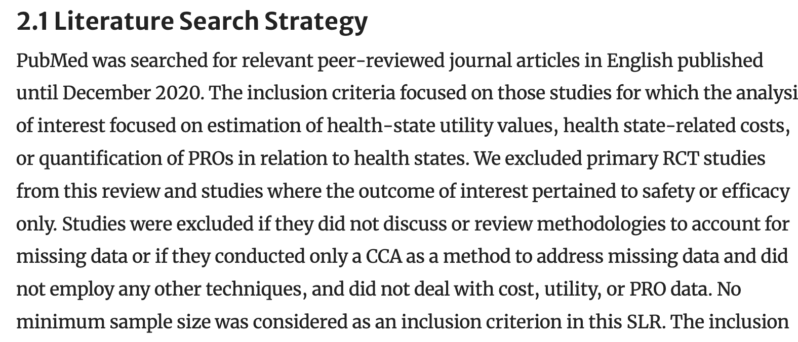

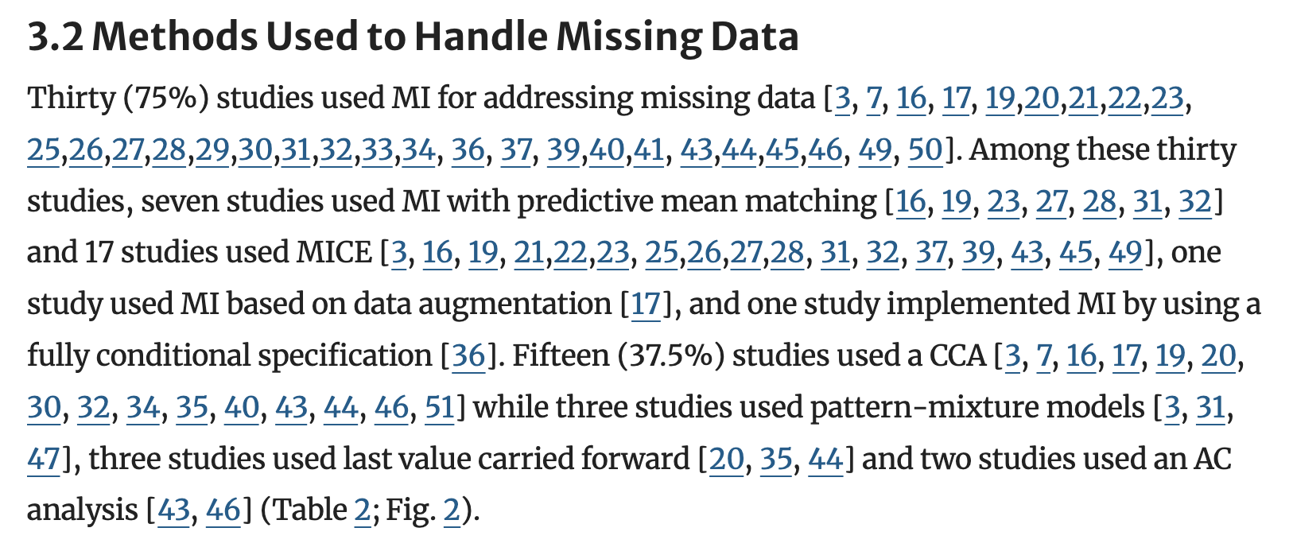 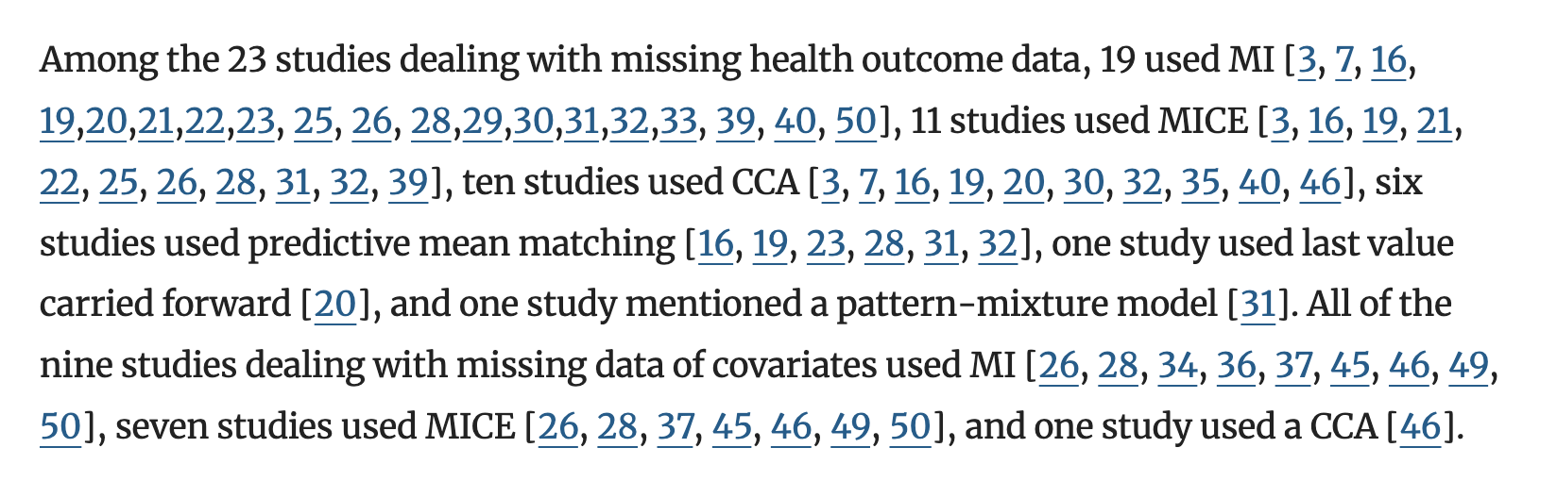

**Addressing Missing Data Challenges in Geriatric Health Monitoring: A Study of Statistical and Machine Learning Imputation Methods**

<https://www.mdpi.com/1424-8220/25/3/614>

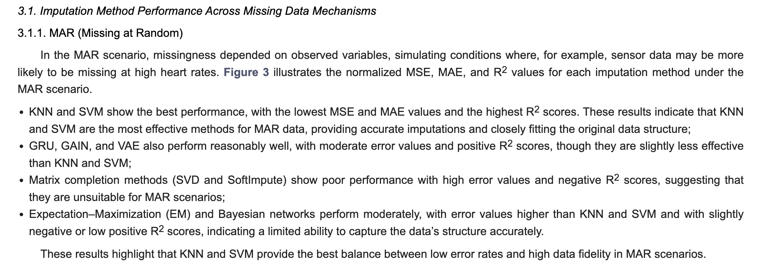

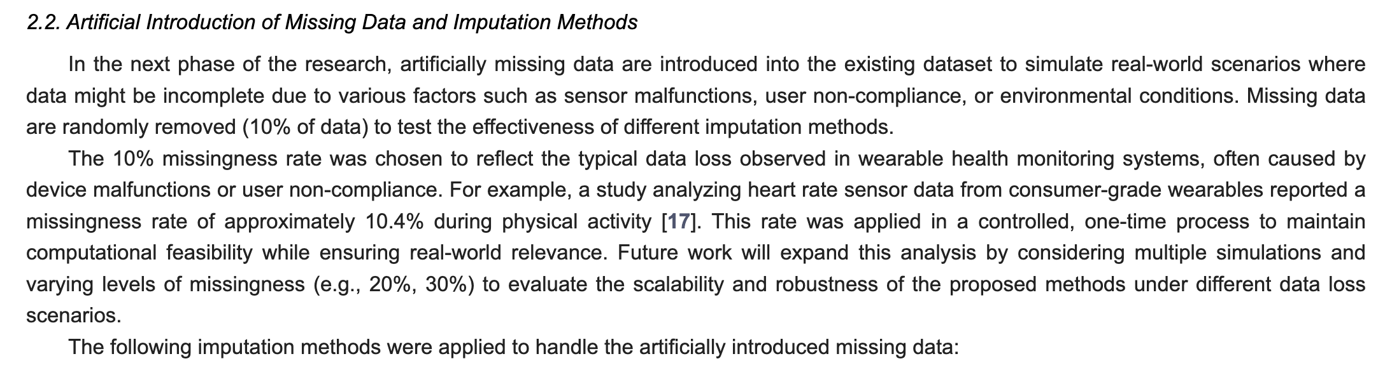

Missing Data Analysis Using Statistical and Machine Learning Methods in Facility-Based Maternal Health Records

<https://link.springer.com/article/10.1007/s42979-022-01249-z>

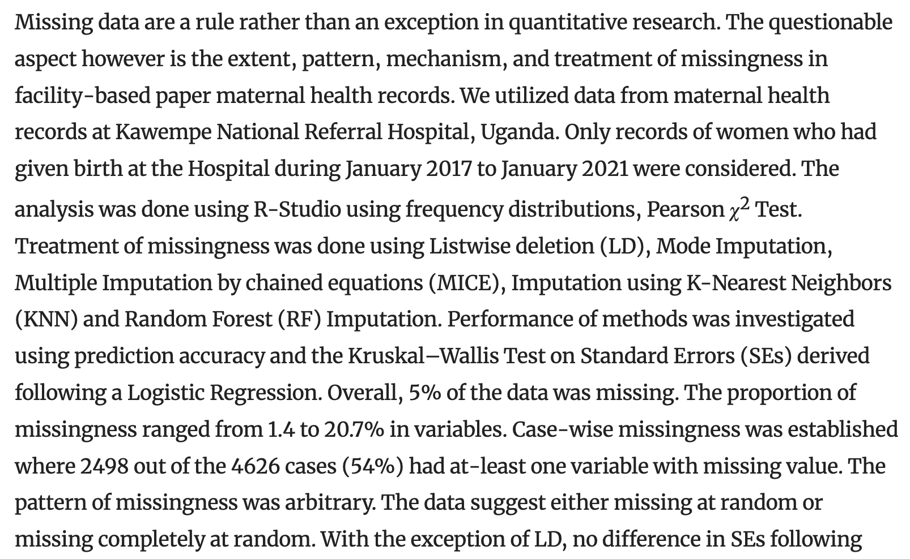

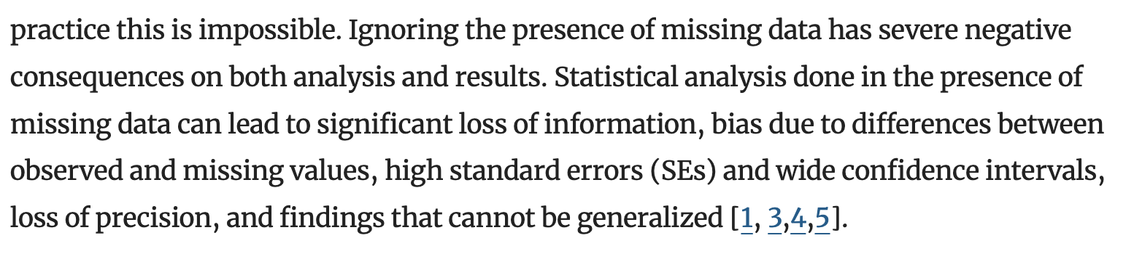

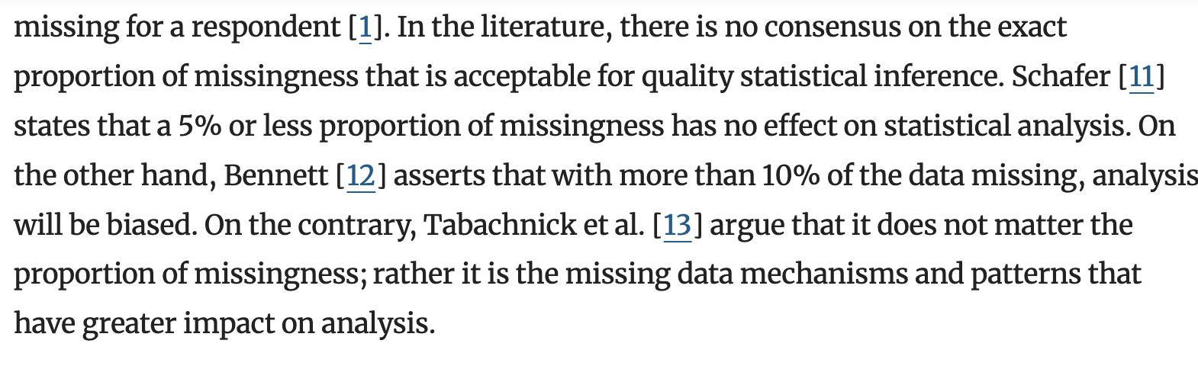 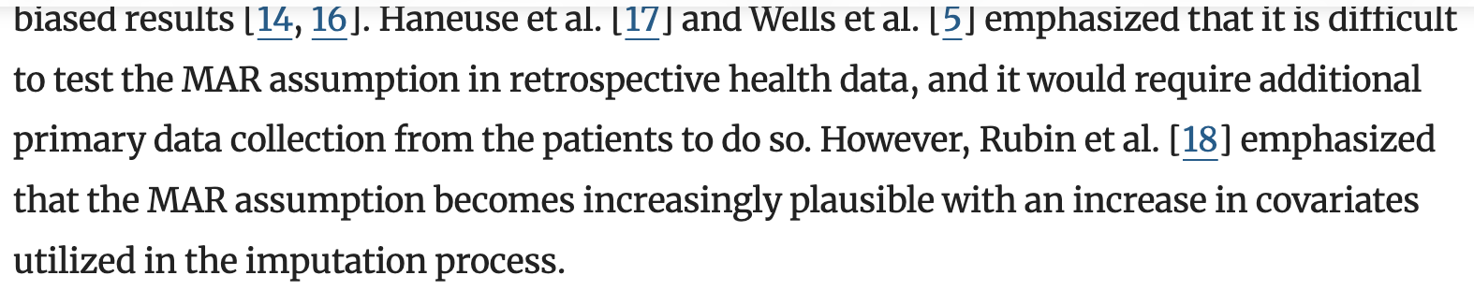

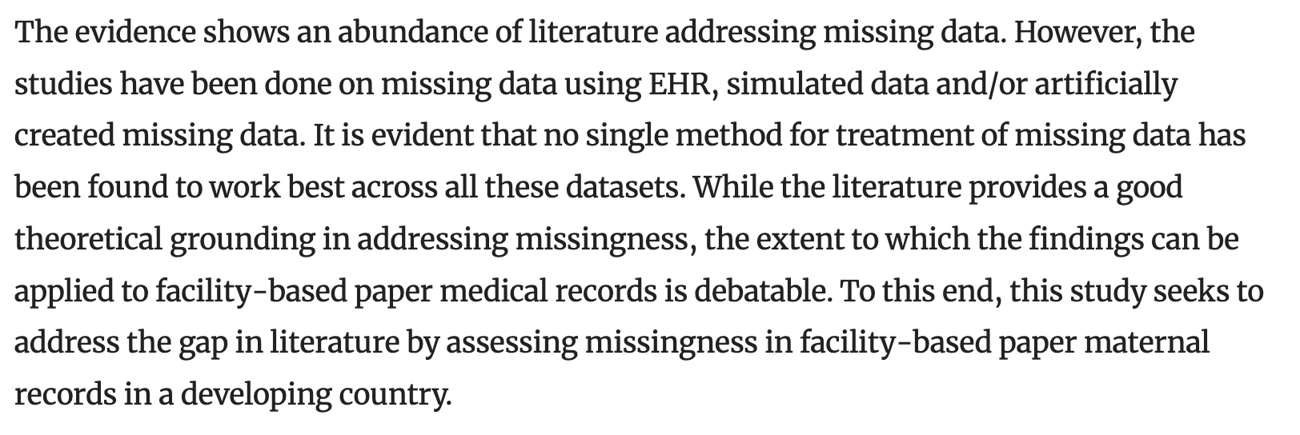

Go to paper to see list of past studies

Lots of data about patient-specific, less about country specific

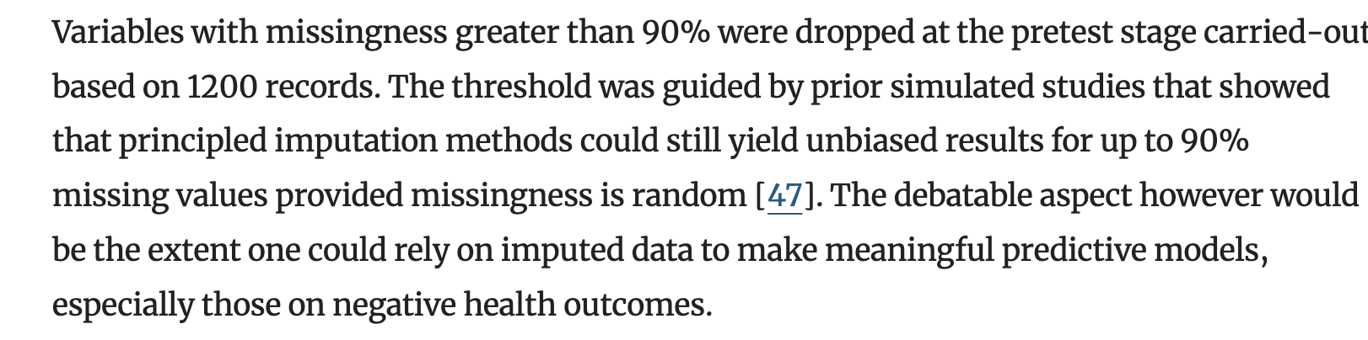

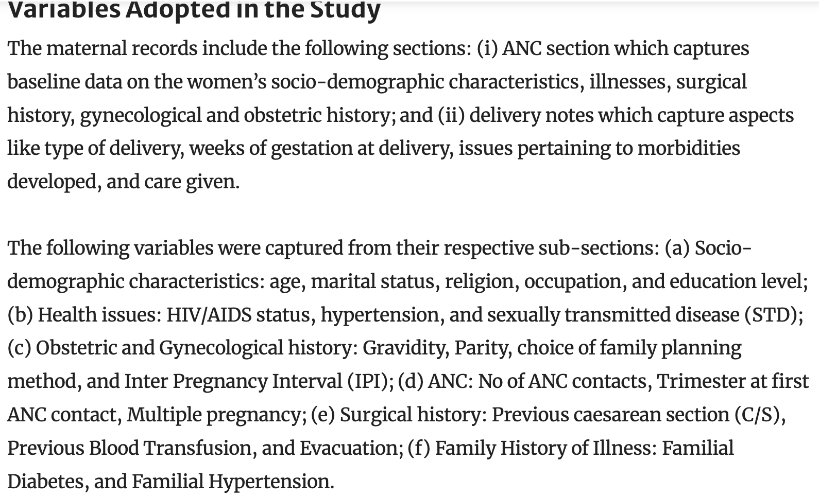

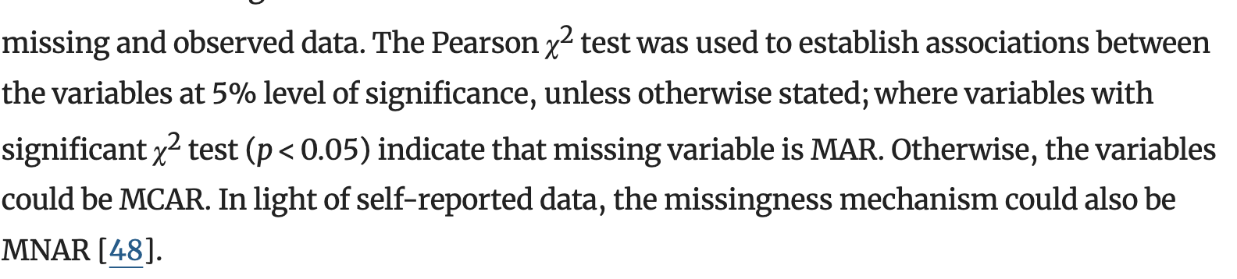 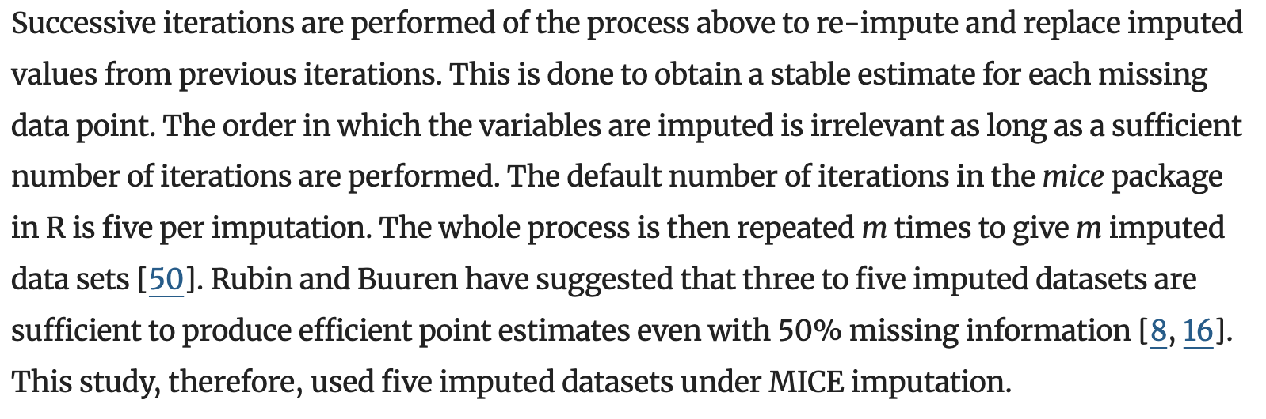 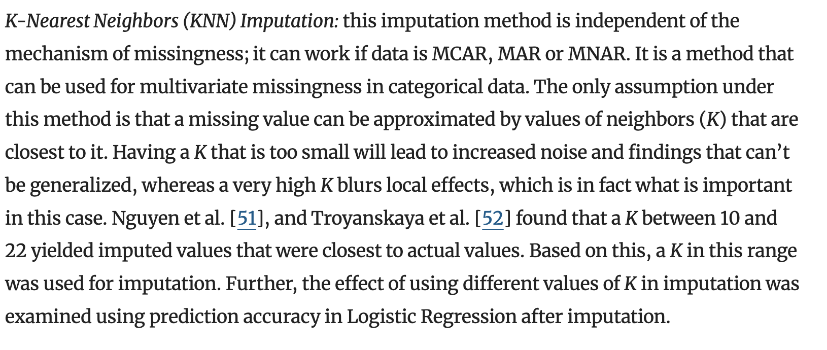 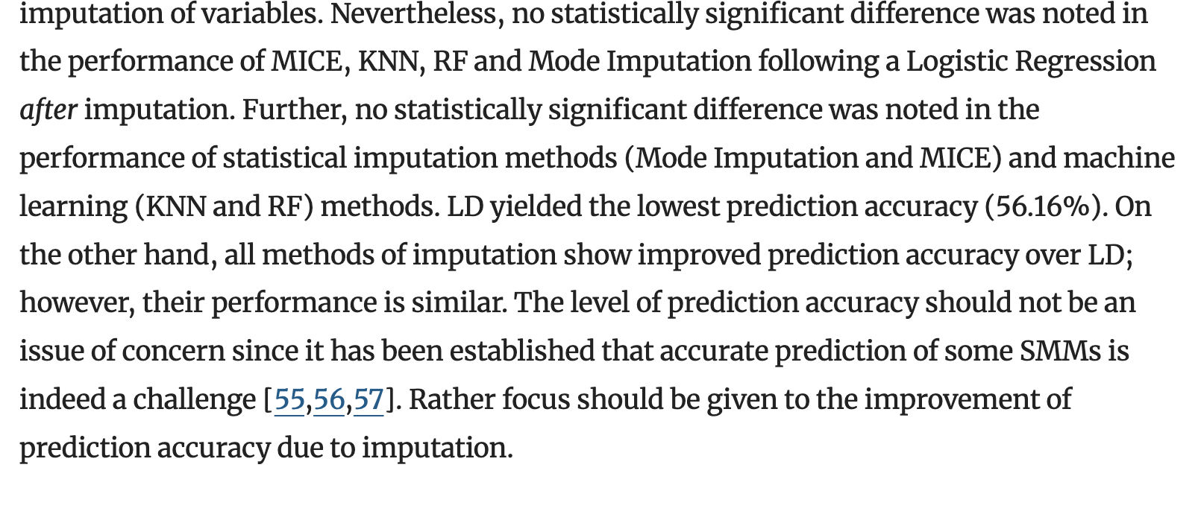

Prediction of adverse pregnancy outcomes using machine learning techniques: evidence from analysis of electronic medical records data in Rwanda

<https://link.springer.com/article/10.1186/s12911-025-02921-z?fromPaywallRec=false>

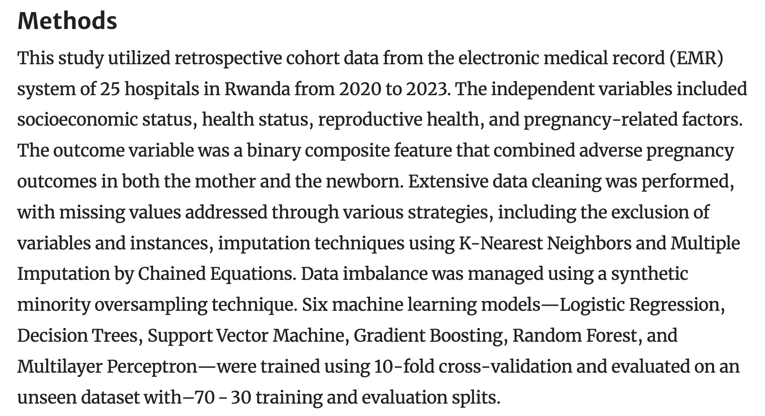

No logistic regression in my study due to so many highly collinear variables

